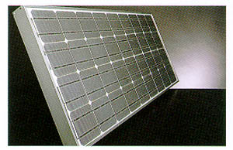
Proposal for
The use of Solar Energy at the
NUS Engineering Faculty
for

Cost Cut Committee 99
by
Cheryl Lian

June Koh
Phang Yean Moi
Megapower Technologies

