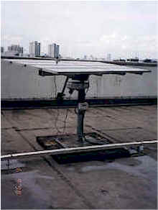
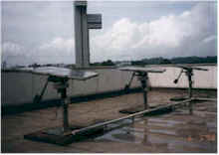
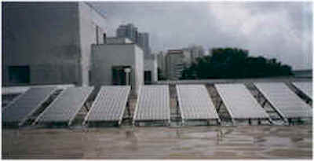
Solar Panels at the Singapore Polytechnic

(Courtesy of Interlink Power Systems Pte Ltd)

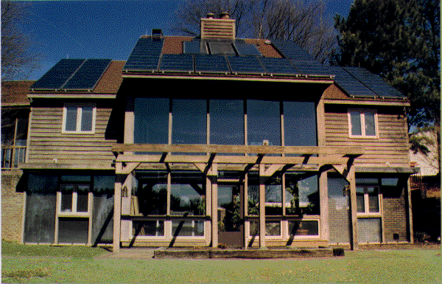
North Carolina Solar House
(Courtesy Of North Carolina University)

