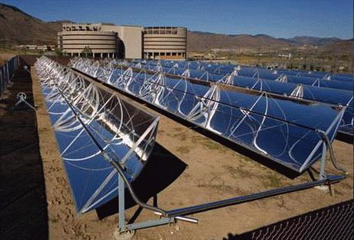

Solar Energy Collectors

(Courtesy of National Renewable Energy Laboratories, Florida, USA)

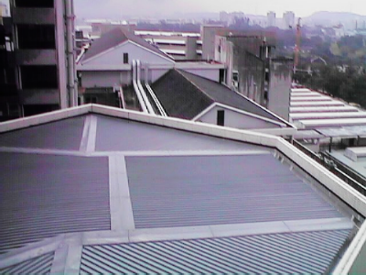

Rooftop View from Engineering Block E4

(To show the availability of rooftop space at NUS)

