Appendix
The Florida “Two Houses” experiment has proven that solar power cuts costs due to its ability to reduce demand. Undeniably, the initial capital costs are high. In a telephone interview with Mr KM Leong, he estimates that the breakeven time is about 20 years, which is the lifetime of the solar panels. With these grim facts, it is still possible to claim that solar power is feasible. This is because by simply installing solar power systems, additional benefits (Section 3: Advantages of Solar Power in NUS) can reaped within the 20-year lifetime.
Data from Worldwatch Institute indicates that from 1971 till 1995, the worldwide prices of solar cells have dropped exponentially from $80 per watt of energy in 1971 to $3 per watt of energy in 1995. (Refer to Figure 3)
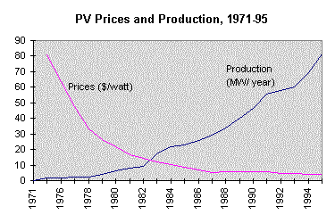

Figure 3
Worldwide Trend of PV Prices and Production 1971- 1995

Indeed, worldwide prices of solar cells has significantly reduced, and this means that
local manufacturers and distributers like Abhirami Electronics and Siemens Showa
Solar Pte Ltd may have to lower their prices to stay in the market. Thus solar power
is progressively getting economically viable and this is a good reason for NUS to
employ the use of solar power.

